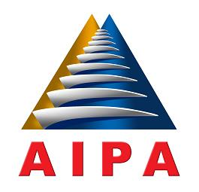

**ASEAN INTER-PARLIAMENTARY ASSEMBLY**

**33rd GENERAL ASSEMBLY**

**16 - 22 SEPTEMBER 2012, LOMBOK, INDONESIA**

**MESSAGE BY H.E. BENIGNO S. AQUINO**

**PRESIDENT OF THE REPUBLIC OF THE PHILIPPINES**

My warmest greetings to the organizers and participants of the 33rd General Assembly of ASEAN Inter-Parliamentary Assembly (AIPA).

The dream of a robust and united Southeast Asia, united in its collective pride and diversity, began with the Bangkok Declaration of 1967. It was a dream that became a more palpable reality, as ASEAN evolved and thrived in the course of its varied eras. Through the dynamic solidarity among our member-governments under the framework of mutual respect and cooperation, and our diplomatic, technical, and cultural exchanges, ASEAN has since reached greater heights, transforming into a significant bloc especially in the political and economic affairs of the region.

The collaborative structure of the AIPA continues to strengthen ASEAN, ensuring that the guiding principles of the organization are interwoven into each of our partner-nation’s laws and policies. May this gathering be another bold step in our integration, that we may sustain our distinction as a vibrant regional community. The Filipino people wish this event success, and we look forward to a peaceful and prosperous future for ASEAN.